Exercise 1 Configuring Basic spring Application

BookService.java-

ckage com.library.service;  
  
  
import com.library.repository.BookRepository;  
  
public class BookService {  
 private BookRepository bookRepository;  
  
 public void setBookRepository(BookRepository bookRepository) {  
 this.bookRepository = bookRepository;  
 }  
  
 public void showBooks() {  
 bookRepository.displayBooks();  
 }  
}

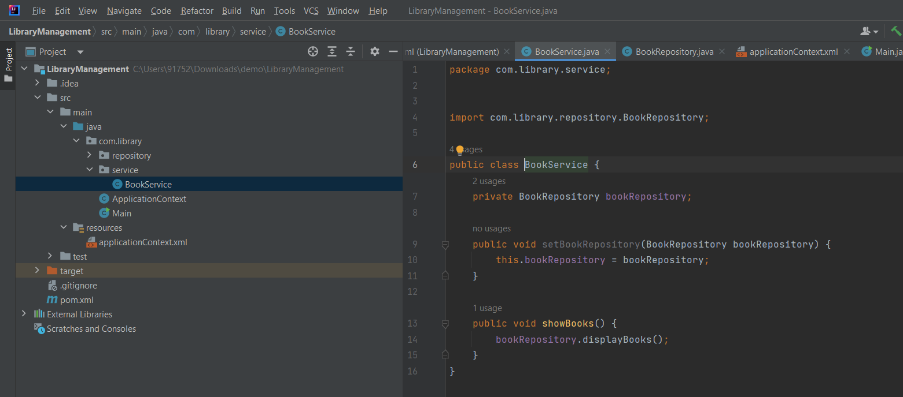

2-BookRepository.java

package com.library.repository;  
  
public class BookRepository {  
 public void displayBooks() {  
 System.*out*.println("📚 Showing all books from repository...");  
 }  
}

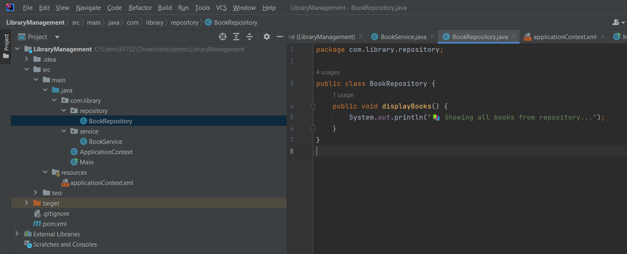

3- Main.java

package com.library;  
  
// Press Shift twice to open the Search Everywhere dialog and type `show whitespaces`,  
// then press Enter. You can now see whitespace characters in your code.  
import com.library.service.BookService;  
import org.springframework.context.ApplicationContext;  
import org.springframework.context.support.ClassPathXmlApplicationContext;  
  
public class Main {  
 public static void main(String[] args) {  
 ApplicationContext context = new ClassPathXmlApplicationContext("applicationContext.xml");  
  
 BookService bookService = context.getBean("bookService", BookService.class);  
 bookService.showBooks();  
 }  
}

3- applicationContext.xml

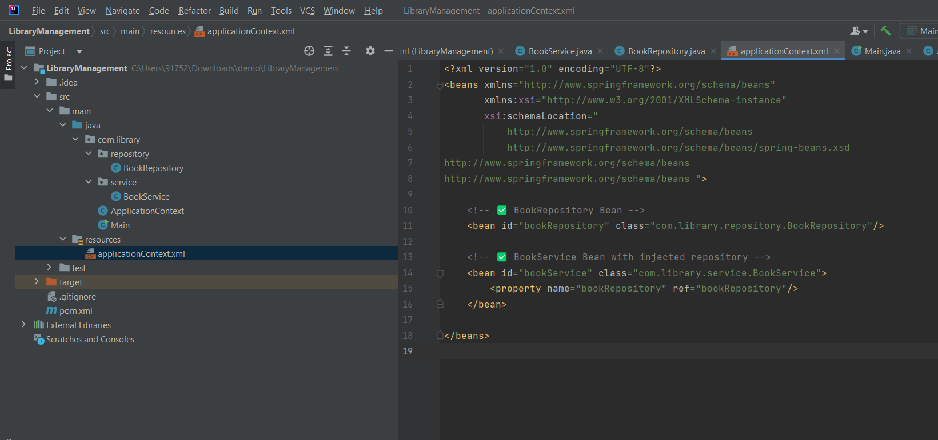

OUTPUT

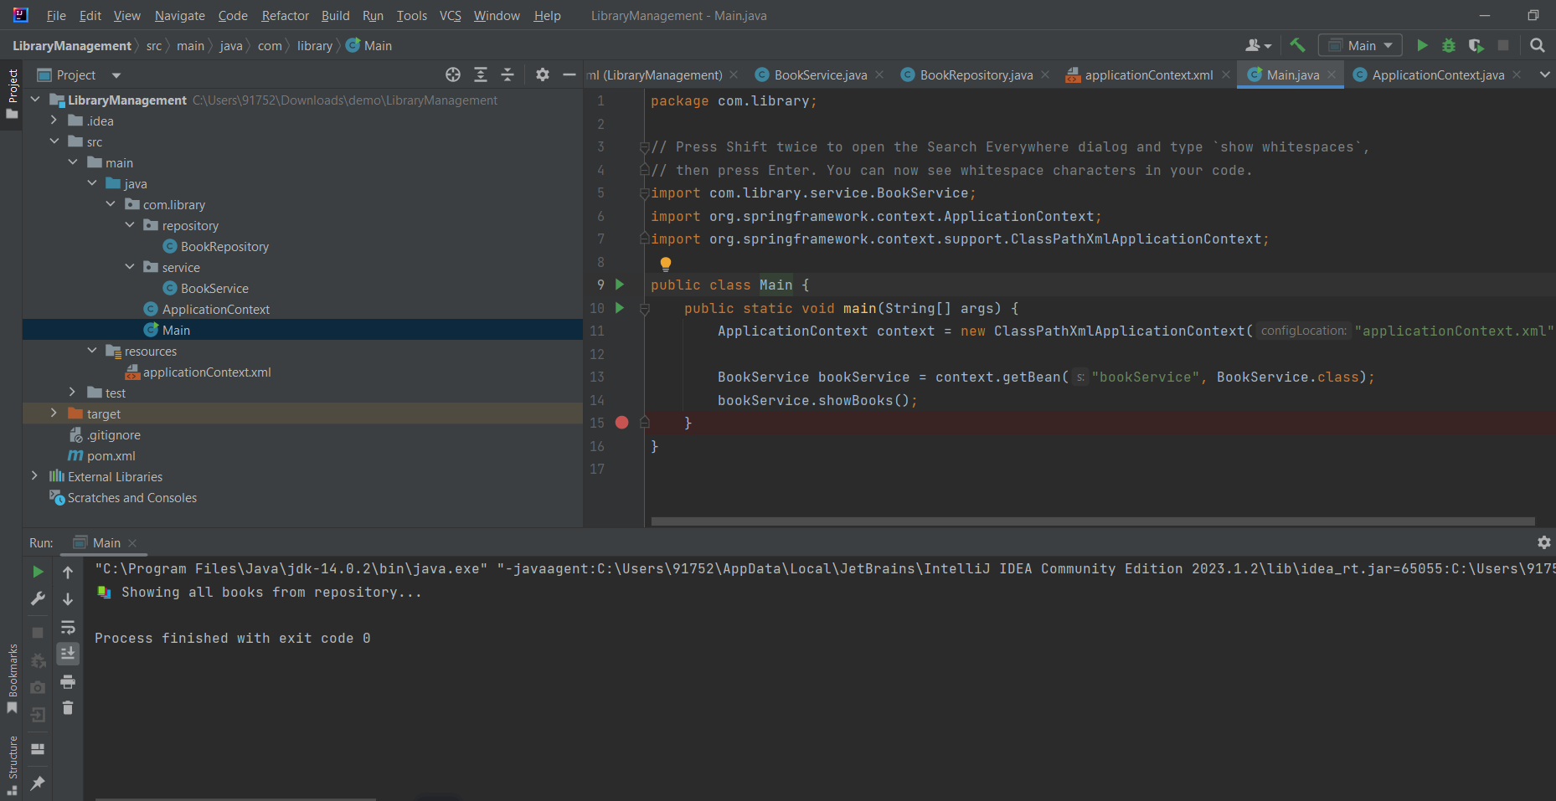

Project structure-

